**User Manual**

**E-Project**

Aptech Garden Center

Karachi, Pakistan

Name : Syed Sohail Abbas Mosvi

Batch : 2209E01

Course : CPISM

Student ID : 1422386

Faculty : Sir Zaman

E-Project Title : Universal Stationary

E-Project Description : Create a full responsive front-end website design using HTML5, CSS3, JavaScript, Bootstrap5.

Software used : Visual Studio Code

**Getting Started**

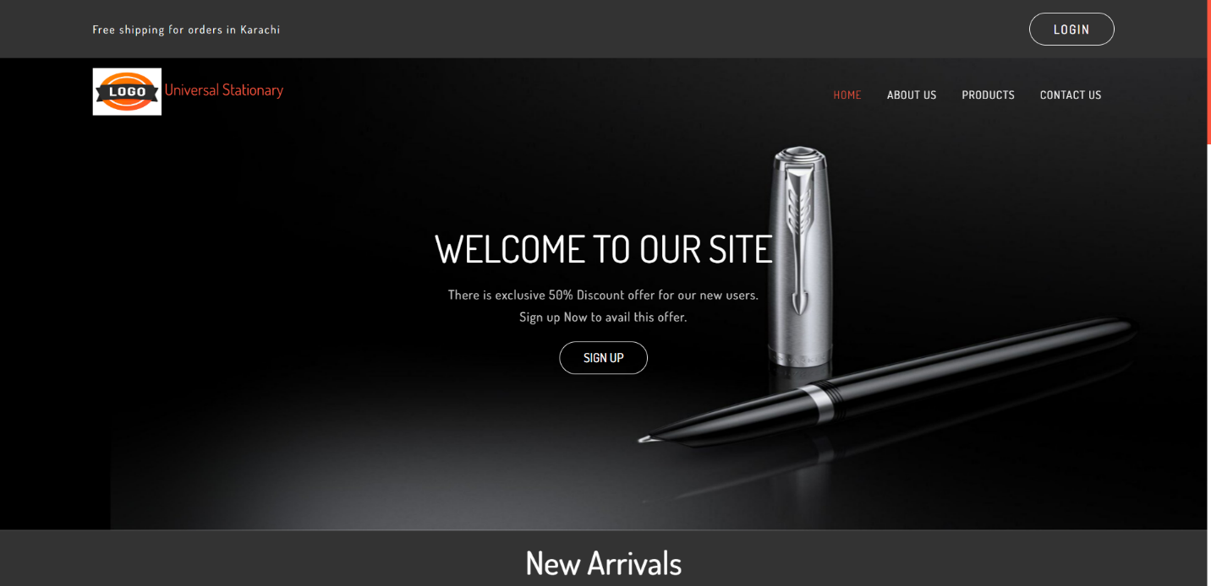First Index Page

This is the first page of the website. Here you can all features of the website. It starts from header part. I have also added a top header which shows a line and there is a login button. After this, there is navigation bar with logo and title.

The first section is banner section. There is a banner and it shows an offer which attracts every new users. Every new user will see this first and will create a new account to avail the new offers.

After Scrolling

Next Section

The next section is New Arrivals section. Here all new products launched by company are shown. The product in center is active which has black background and red borders. User can move these products by using buttons or by scrolling too.

After Scrolling

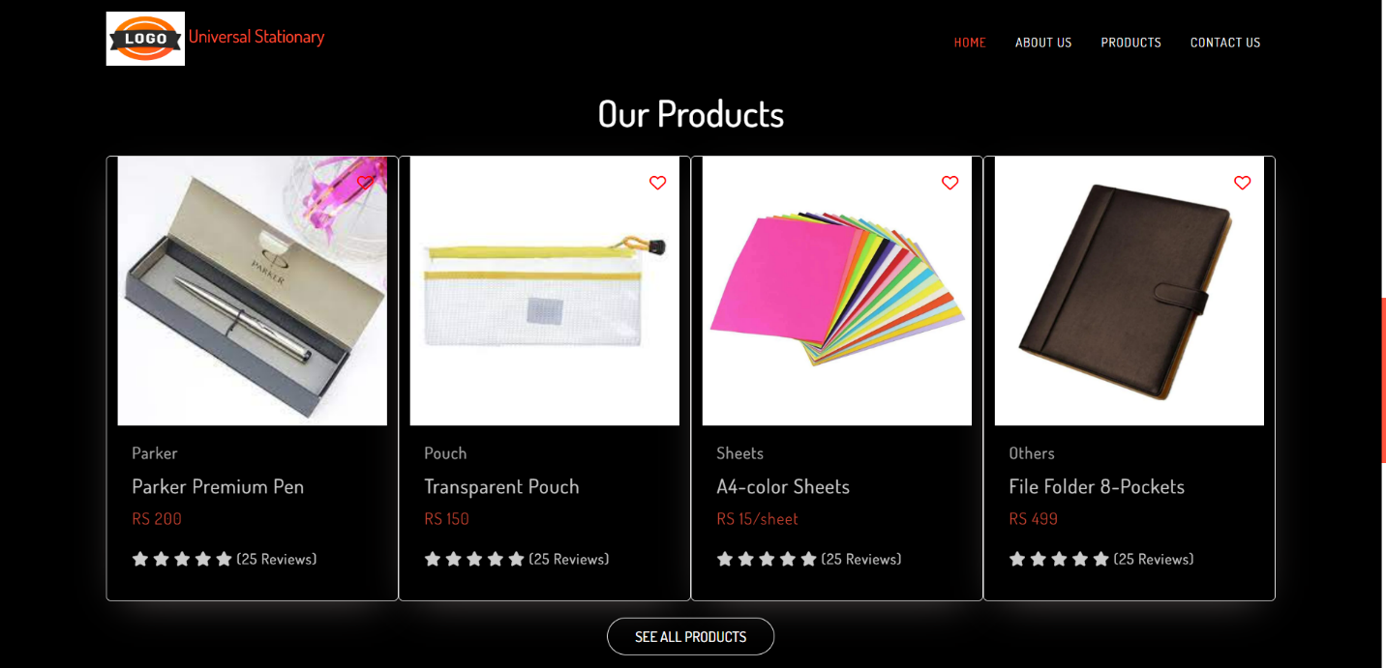Next Section

Now, the products section come after scrolling. Here you can see our featured products. After featured products, there is a button to see all products. By clicking it, you will go to the products page to explore all products.

After Scrolling

Next Section

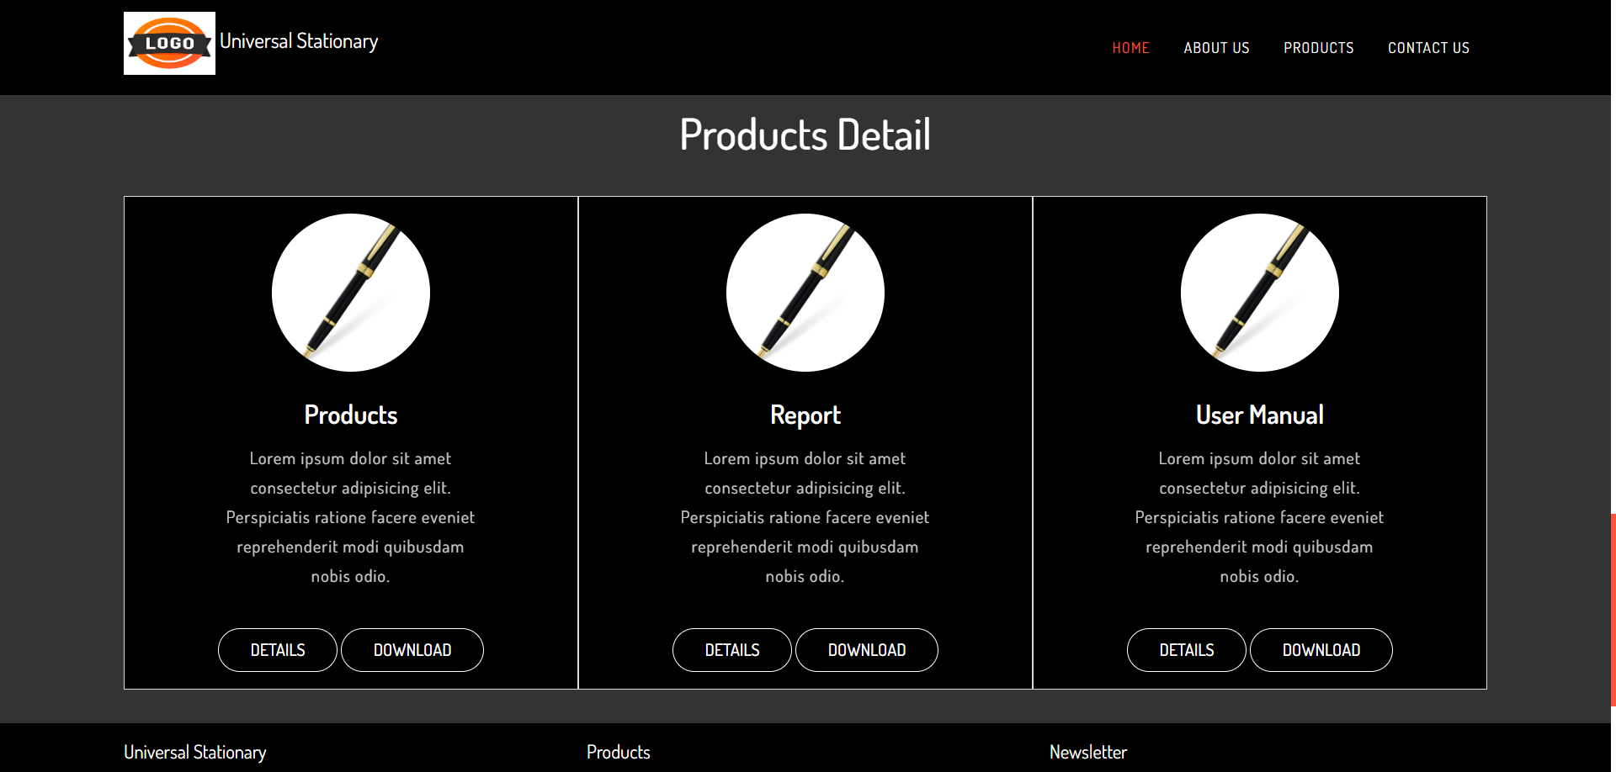

This section is to show all features of our brands and products. I have created one button for products, one for reports and the last one for user manual for e-project.

After Scrolling

Next Section

The last section is for footer. You can navigate to any page of the website by footer. There is also a subscription box, by subscribing you will get notified when any new product or deal is launched. After this, our social media accounts are linked so that you can contact us for more information and queries.

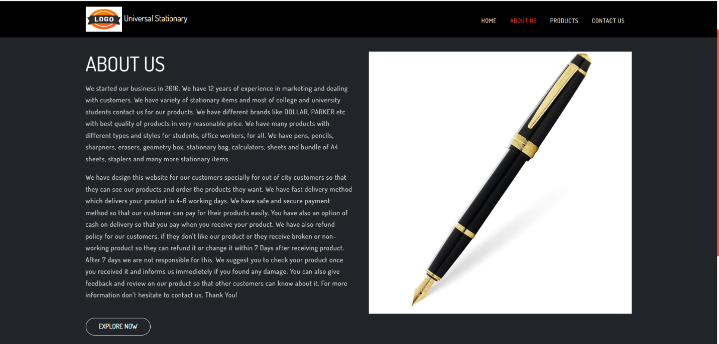Second Page

The second page of the website is “About Us” page. In this page you will get information about the website, that how this website is created and so more.

After a brief description of the website, you will see a “Explore Now” button. By clicking it you will navigate to the products page.

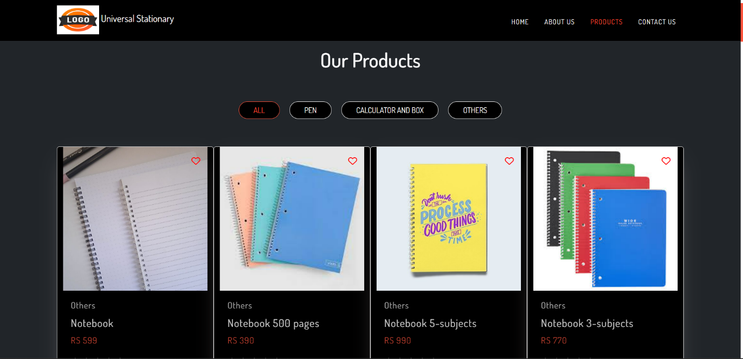Third Page

This page is the main page of the website. It contains all the products in this page. There is some navigation links which shows different products according to the categories. In all tab, you can see all products and in pens tab you can see only available pens products. Like this other category shows only their available products.

Last Page

At last, there is contact us page. There are two sections in this page. The first section will show the location of our shop and contact information. You can send email by clicking our email address and you can direct call us by clicking on number. The next section has a contact us form. To submit this form, all fields must be filled correctly.

So, this was our website and user manual/guide for our website. Hope you will like this.

**Thank You!**